**CONTENTS**

|  |  |  |
| --- | --- | --- |
| **S.No** | **Topics** | **Page. No** |
|  | **List of Figures** | **iv** |
|  | **List of Tables** | **vi** |
|  | **Abbreviations** |  |
|  | **Abstract** | vii |
| 1 | **Introduction** | 1 |
| * 1. Motivation | 1 |
| * 1. Objective of the Project | 1 |
| 1.3 Problem Statement | 1 |
| 2 | **Existing System** | 2 |
| 2.1 Literature survey | 2 |
| 3 | **Proposed Methodology** | 3 |
| 3.1 System Specifications | 3 |
| 3.2 System Design | 4 |
| 3.3 Proposed Work | 5 |
| 4 | **Implementation and Results** | 6-17 |
| 5 | **Conclusion and Future Scope** | 18 |
|  | **Bibliography** | 19 |

**List of Figures**

|  |  |  |
| --- | --- | --- |
| **Figure No** | **Name of the Figure** | **Page No** |
| **1** | **implementation of code** | **8** |
| **2** | remainder app | **8** |
| **3** | Alert Message | **9** |
| **4** | Set Notification | **9** |
| **5** | Notification | **10** |
| **6** | Stop Notification | **10** |
| **7** | Event | **11** |
| **8** | Create the Event | **11** |
| **9** | Trigger | **12** |
| **10** | Trigger with time and date | **13** |
| **11** | Action | **14** |
| **12** | Message | **15** |
| **13** | Finish | **16** |
| **14** | Message Notification | **17** |
| **15** |  |  |
| **16** |  |  |
| **17** |  |  |
| **18** |  |  |
| **19** |  |  |
| **20** |  |  |
| **21** |  |  |

**List of Tables**

|  |  |  |
| --- | --- | --- |
| **Table No** | **Name of the Table** | **Page No** |
|  |  |  |
|  |  |  |
|  |  |  |
|  |  |  |
|  |  |  |
|  |  |  |
|  |  |  |

**ABSTRACT**

Today, people have many activities throughout the day, ranging from a small thing to many other big things. Many of the applications on the smart phone is used to manage time efficiently throughout the day. But, most of the existing applications do not have social networking capabilities. In this project, we propose an application using GUI python. The app is designed to be an easy-to-use application with the main goal of helping users to remind about the special events in their busy life by providing timely alerts.

The application consists of task setting, birthday reminders, social sharing etc. All functions of the app are combined to provide the best time management assistant, which suits for everyone.

1. **Introduction**

There are bunch of schedule reminder android applications available today on play store providing static notification to user before a specified interval of time. Remind My Schedule is a solution to the above problem. This is a location based reminder application which dynamically notifies user so that they can be on or before time for an event

* 1. **Motivation**

Today, people have many activities throughout the day, ranging from a small thing to many other throughout the day. big things. Many of the applications on the smart phone is used to manage time efficiently .we introduced this remainder application .so,our motive to alert the people at sequence of time

* 1. **Objective of the Project**

The main objective of the project is based on creating a remainder app . This is similar to a notification remainder to take a break for relaxing ,drink water and greet user based upon the time. We see that when we involved in some work or other we loose track of time and forget to even have food for both mind and body.Unless someone reminds us to have food or water we forget and neglect to drink water. The main purpose of this application is to allow users to create remainder based on the location and notify to users with those remainders automatically.

## Problem Statement

All the information Cute Reminder stores for you is classified depending on how it relates to a time. Reminders are pieces of information tightly bound to a specific time.

1. **Existing System**

Strategic planning fails is an assertion that strategic planning fails in the first place and that the causes might not be well understood. The reasons why strategic planning fails and the rate of failures should not be a surprise to anyone since it would perpetuate another fallacy of planning. Organizations devote so much time and energy to the annual ritual of developing or updating their strategic plans if they are doomed to failure from the start. Just think of all of the smart, well-educated, experienced managers and executives devoting so much of their organizations limited resources on an activity with such a poor track record of producing results.

In the present market we can observe there are many remainder application that people discovered like google calender ,android application on remainders and on cloud computing etc..

These are all existing system on remainder application .but, we proposed a gui application which easy to user understand the process.

## Literature survey

For remainder application we referred some textbooks like python7 ,player python documentation website, github and some websites

**3.Proposed Methodology**

3.1 System Specifications

Operating System: Windows 7

Languages used: Python with IDLE

In order to run and modify this program on your personal machine, you will need to have installed the following modules/libraries via computer command.

* Tkinter
* Pip install pillow
* pip install plyer

## 3.2 System Design

trigger

Finsh

Action

Create

Time

Set Notification

Text Message

Task

Event

Remainder App

Stop Notification

3.3 Proposed work

This application is intended to be more useful than existing schedule reminder application by offering dynamic notifications to user. The application manages the event schedules for user by keeping track of all the scheduled events. It runs in background to access user’s current location and also calculates the travel time needed depending upon the mode of commute. The calculation results are then used to notify user dynamically.

The present project is a remainder application . This application intelligently notifies user about the event prior enough so that user can reach event location on time. The accuracy and efficiency of application to send dynamic notifications relies upon the profiling done by user. The accuracy of notification is directly depended upon the frequency of location access. More frequently the location is accessed more accurate is the result. But frequent location access while application runs in background could reduce the battery life of device.

**4.Implementation and Results**

In order to run and modify this program on your personal machine, you will need to have installed the following modules/libraries via computer command.

* **from tkinter import \***
* **from PIL import Image, ImageTk**
* **from plyer import notification**
* **from tkinter import messagebox**
* **from PIL import Image, ImageTk**
* **import time**
* **import os**

**From PIL import Image ,ImageTk module is used for**

A class in Tkinter called PhotoImage class is used to display grayscale images or real color images in Tkinter.The format of these images can be of various types including png, jpeg, gif, tif, ppm, bmp, etc.The image.open(file to be opened) method is used to open the file which searches for the specified file in the program directory.For the PhotoImage class, image.open(file to be opened) method to work, Python Imaging Library, or PIL must be installed which allows loading of images.The corresponding PIL module is present in PyPi which can be installed using the pip package manager.

## Module Needed

Time: This module works with the time object and is installed by default

Plyer: Plyer module is used to access the features of the hardware. This module does not comes built-in with Python. We need to install it externally. To install this module type the below command in the terminal.

To install plyer package in python .we need to install ‘pip install plyer’ in command prompt

For importing imagetk in code .we need to install ‘pip install pillow ‘ in command prompt

## Pseudo code

Step 1 : Import the notification class from the plyer module and all packages

from plyer import notification

Step 2: we create a class obj which invoke the function task and event

Step 3 : In task we create another function get_details in the get details function we create the title,msg,time .

Step 4 : In the get_details function we created loop like if we user give the title ,msg,time in the messagebox give the notification or else return to error message

Step 5 : After that you just need to call the notify method of this class.

Syntax: notify(title=”, message=”, app_name=”, app_icon=”, timeout=10, ticker=”, toast=False)

### Parameters:

title (str) – Title of the notification

message (str) – Message of the notification

app_name (str) – Name of the app launching this notification

app_icon (str) – Icon to be displayed along with the message

timeout (int) – time to display the message for, defaults to 10

ticker (str) – text to display on status bar as the notification arrives

toast (bool) – simple Android message instead of full notification

“” notification.notify(title=get_title,

message=get_msg,

app_name="Notifier",

app_icon="ico.ico",

toast=True,

timeout=10)””

Step 6 : And we create stop_notify to get the notification in multiple time according to time break given by user .we used threads to get notification in multiple times.thread get called by start method.

Step 7 : we created messagebox after setting the notification in the get_details.if user press ok notification get start.

Step 8 : While thread is running we created a messagebox to stop the notification . we created stop function to stop the running Thread

Step 9 : Add the sleep function to show that notification again.

Step 10 : For Event statement we imported os module .give the path of the event.

Step 11 : END

**Below is the implementation.**

**Fig(1): implementation of code**

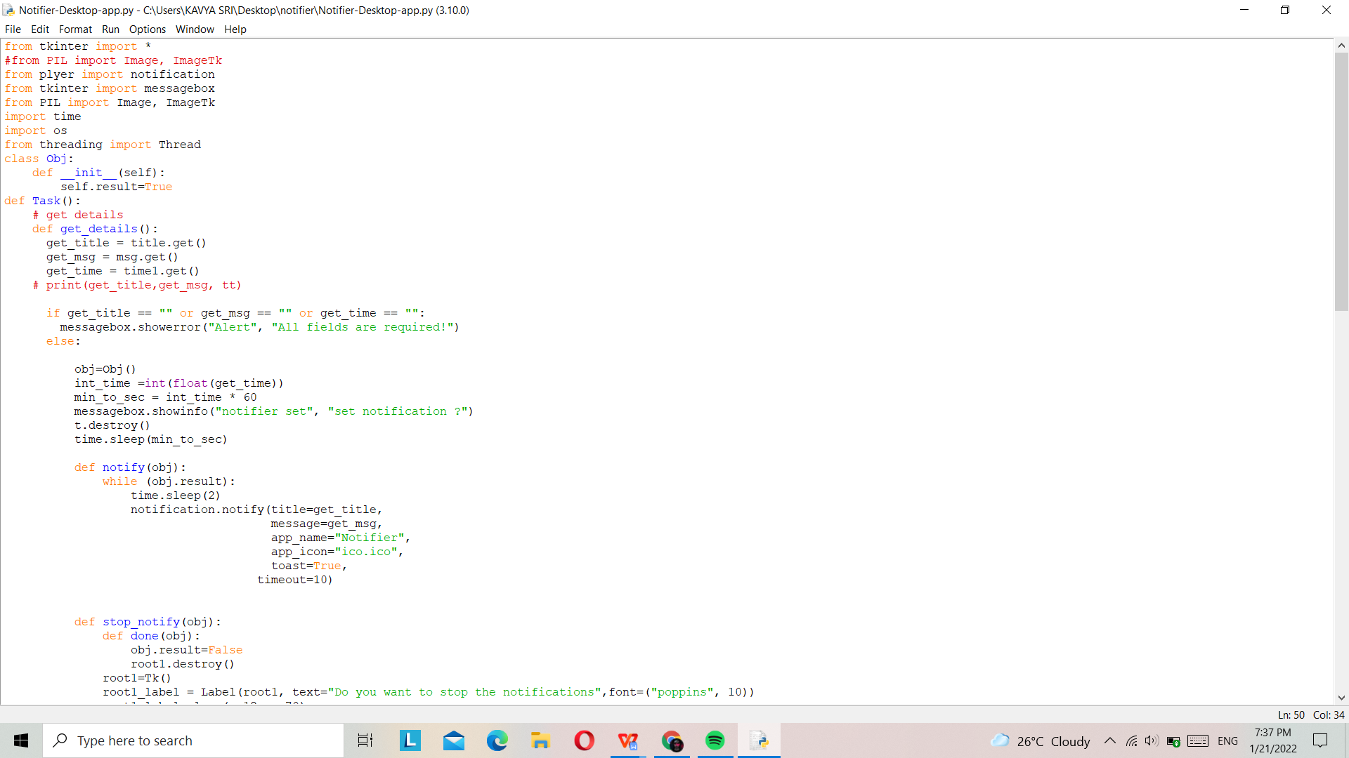

## **Below is the Result.**

Fig(2) remainder app login page with task and event buttons .

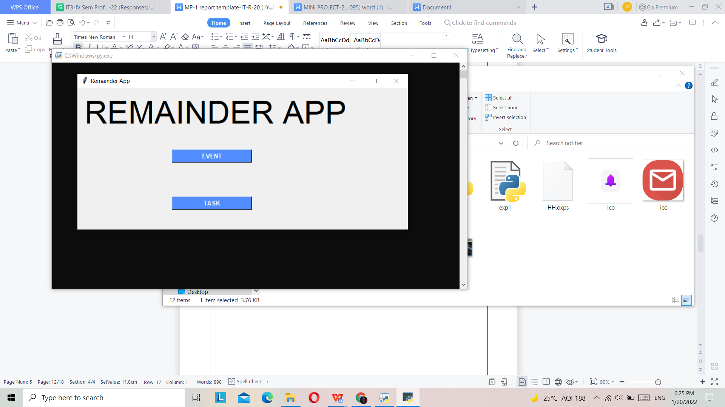

Fig(3) : Alert Message

In set notification we give the message to be notify

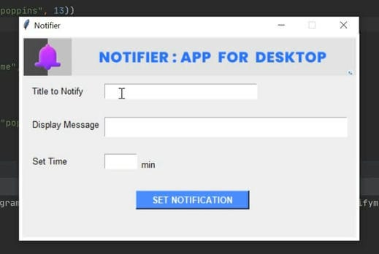

Fig(4) : Set Notification

In fig (4) a message pops up to set the notification and ‘ok’ button .

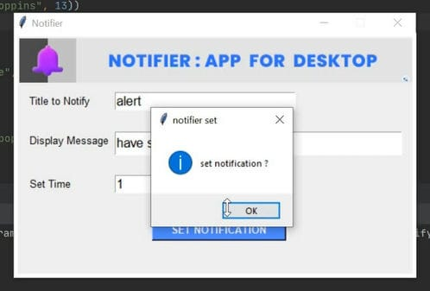

Fig(5) : Notification

In fig(5) notification get start on desktop.

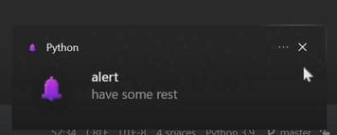

Fig(6) : Stop Notification

When notification get started the messagebox pops up to stop the running notification.

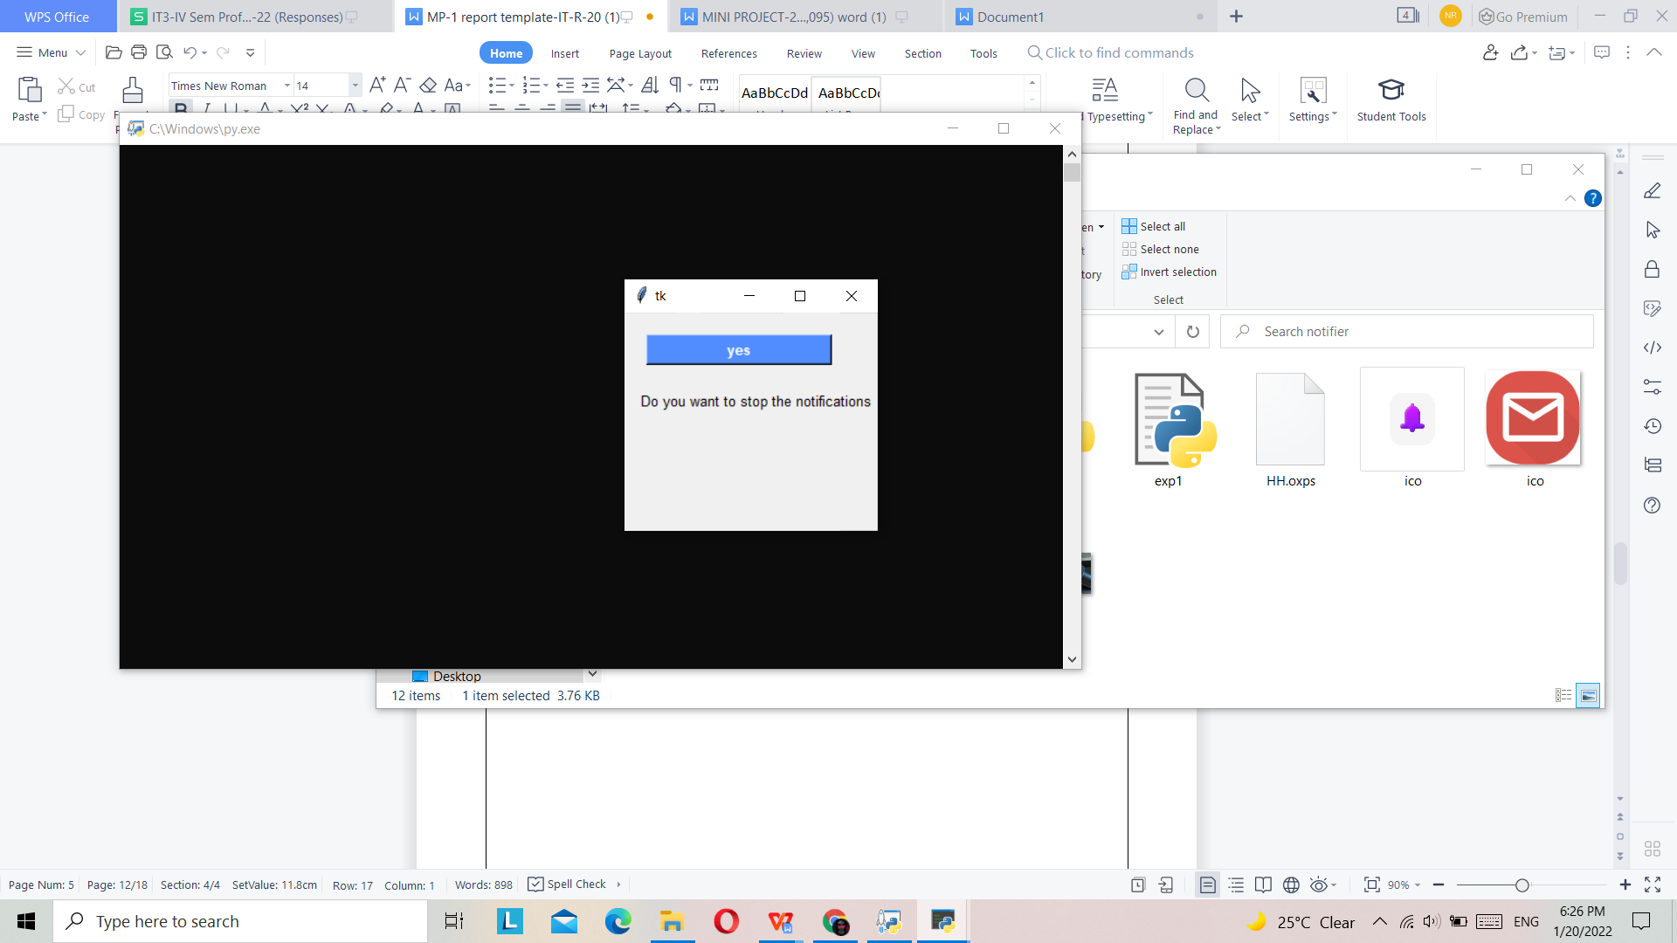

Fig(7) : Event

When user click the event button in the login page .the event page get start the process.

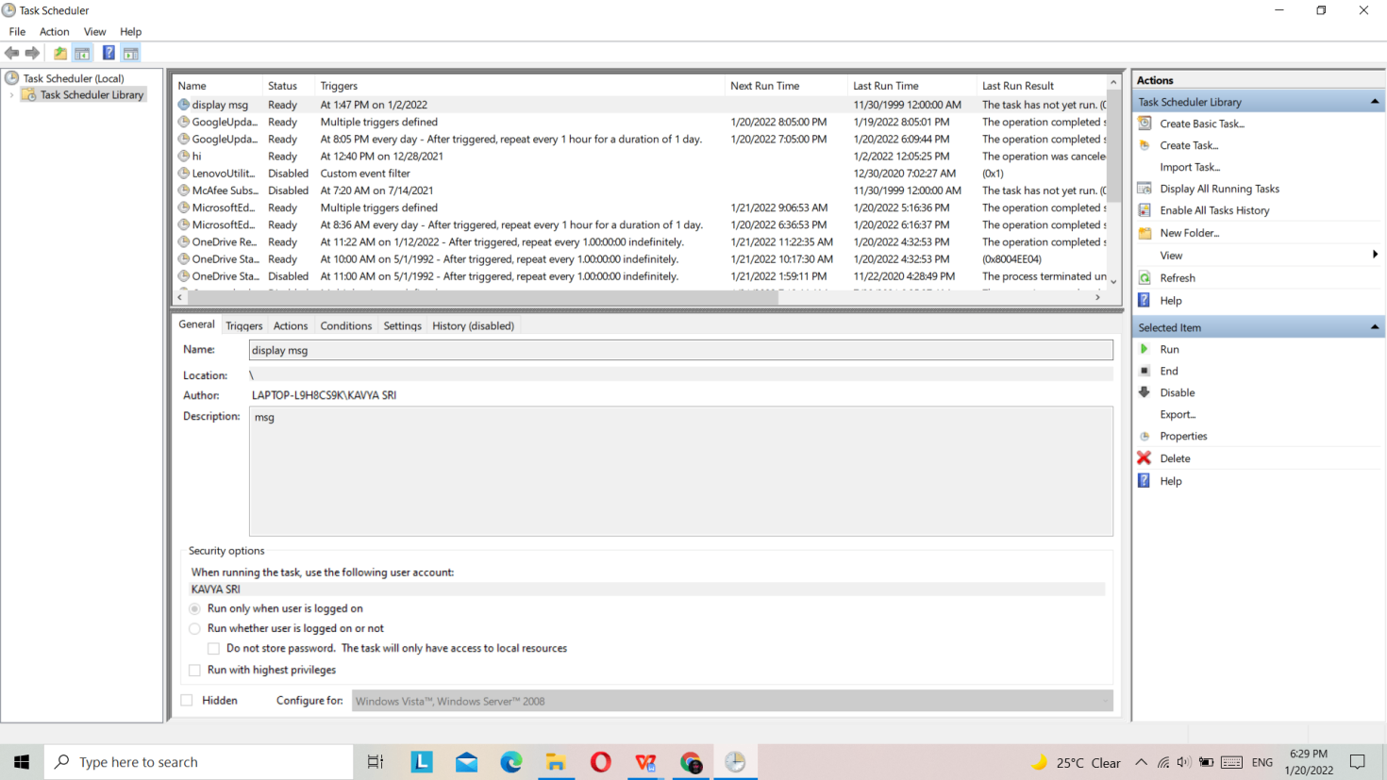

Fig(8) : Create the Event

Here we click the create the basic task button .To create an event.

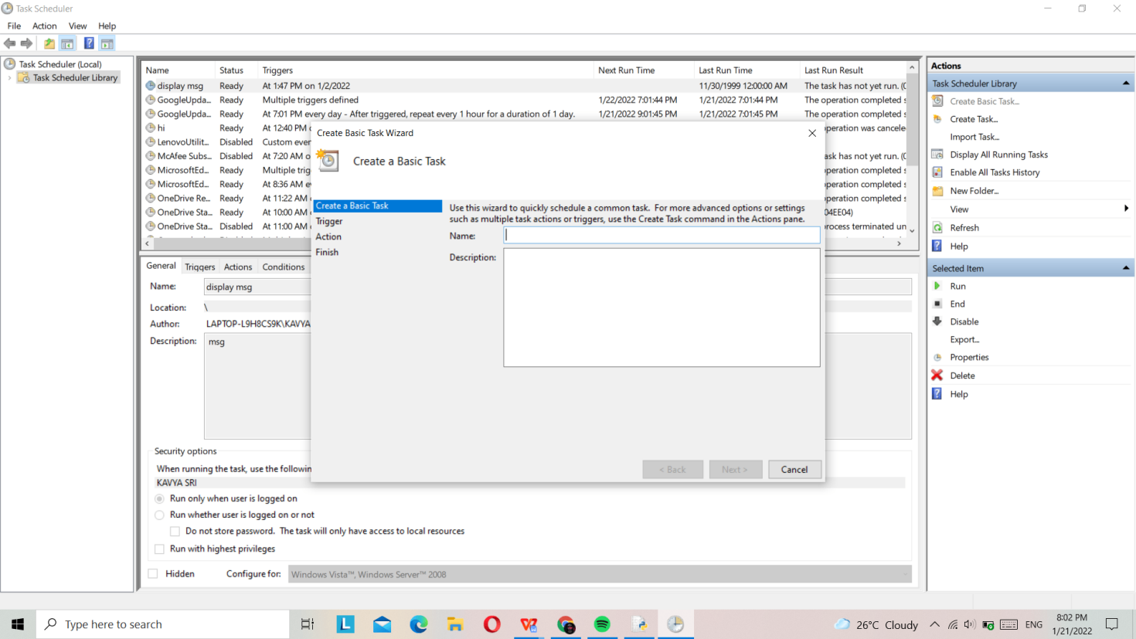

Fig(9) : Trigger

In fig(9) we set the trigger like daily,weekly,monthly,one time etc..

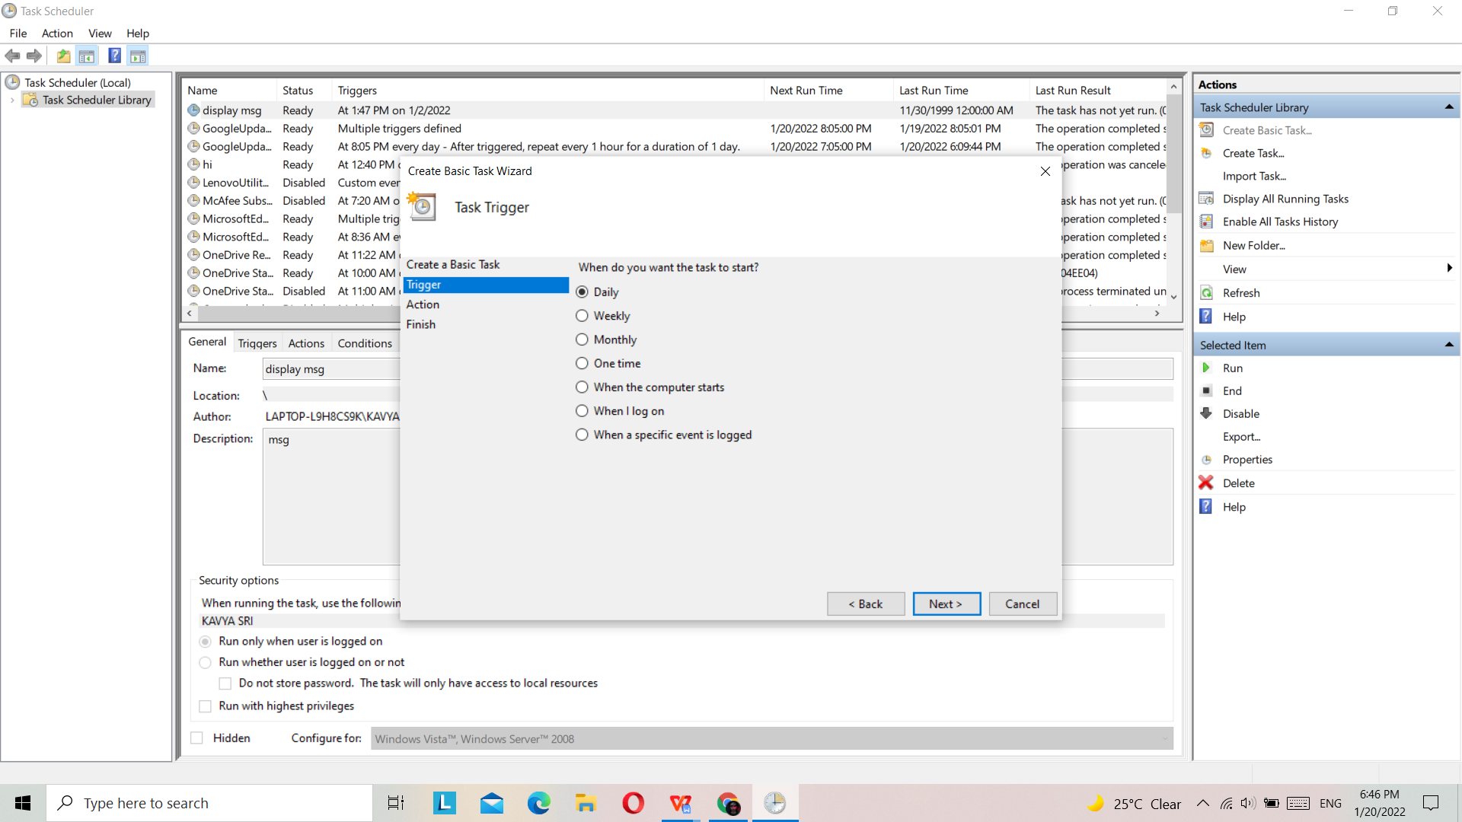

Fig(10) : Trigger with time and date

In fig(10) we set the time and date to notify the message

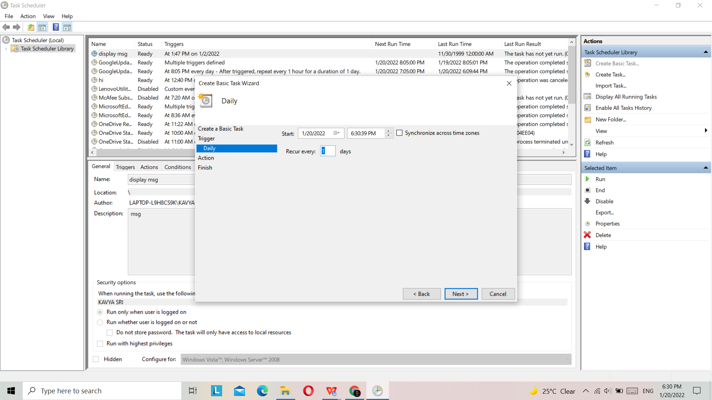

Fig(11) : Action

Display a message

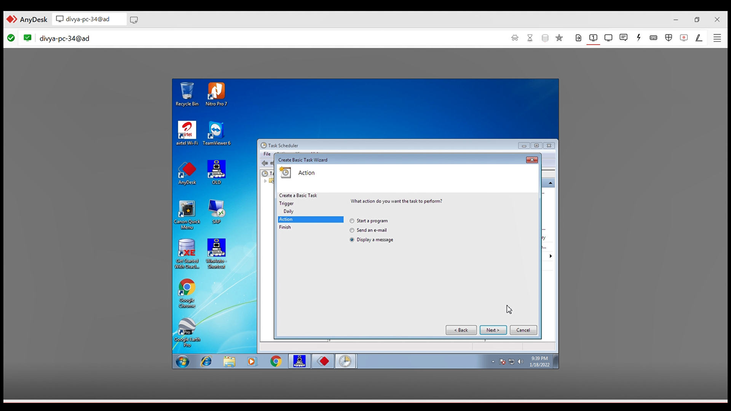

Fig(12) : Message

Message to remaind

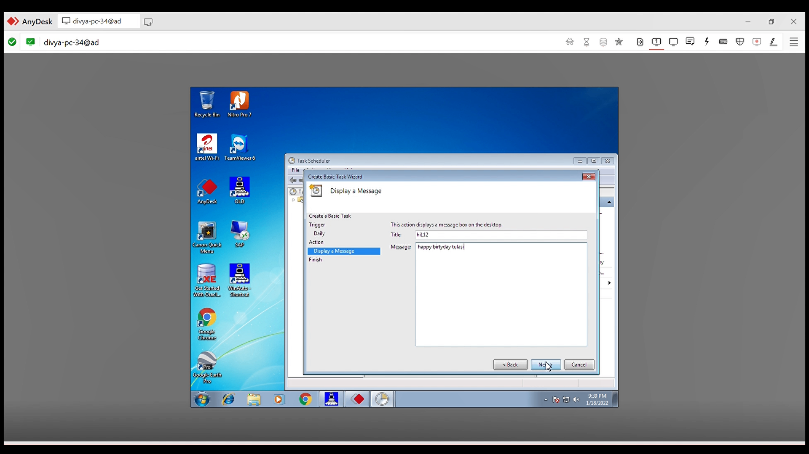

Fig(13) : Finish

Finishing

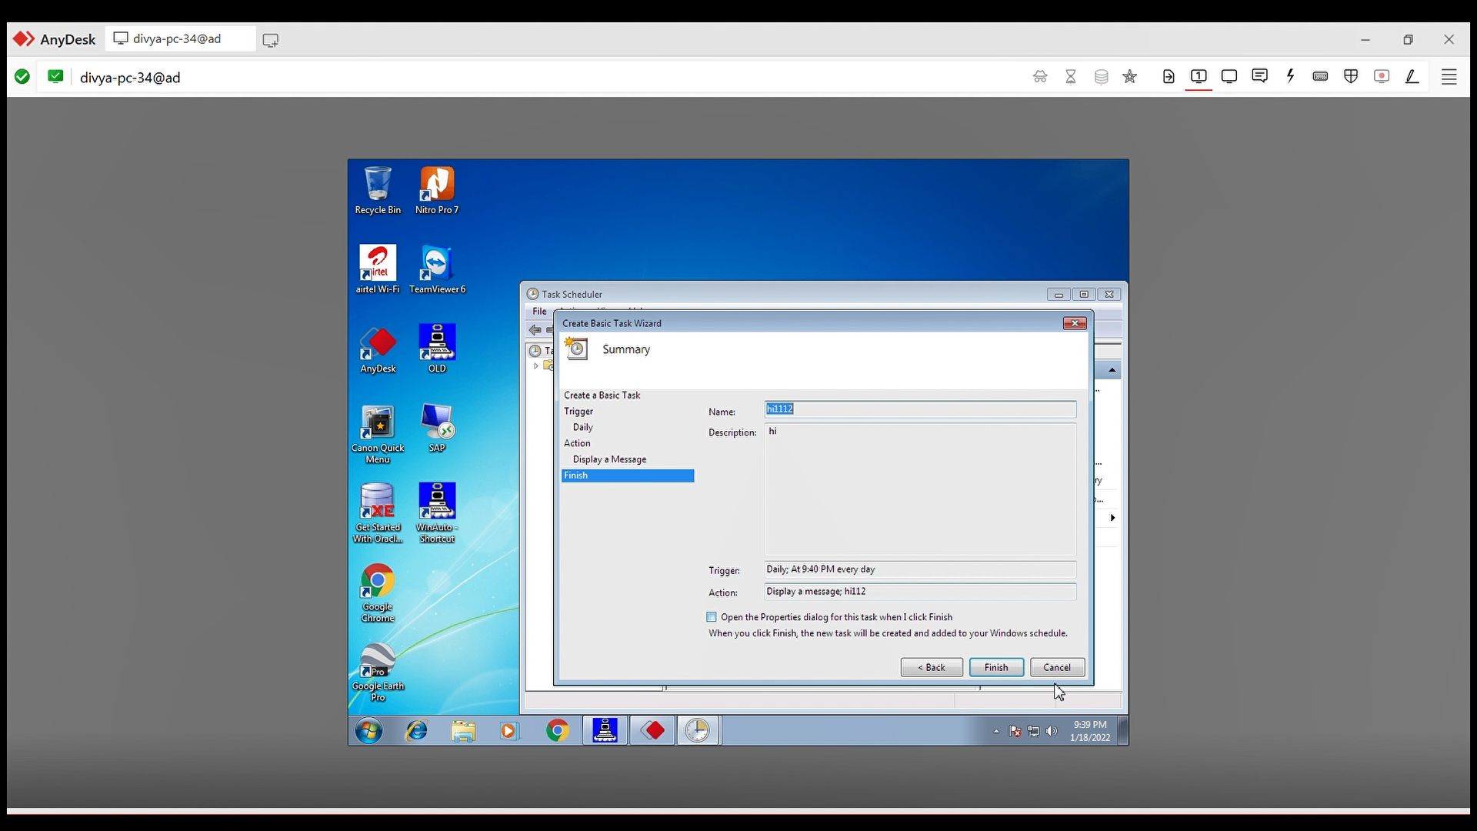

Fig(14) : Message Notification

Popped up message at particular time

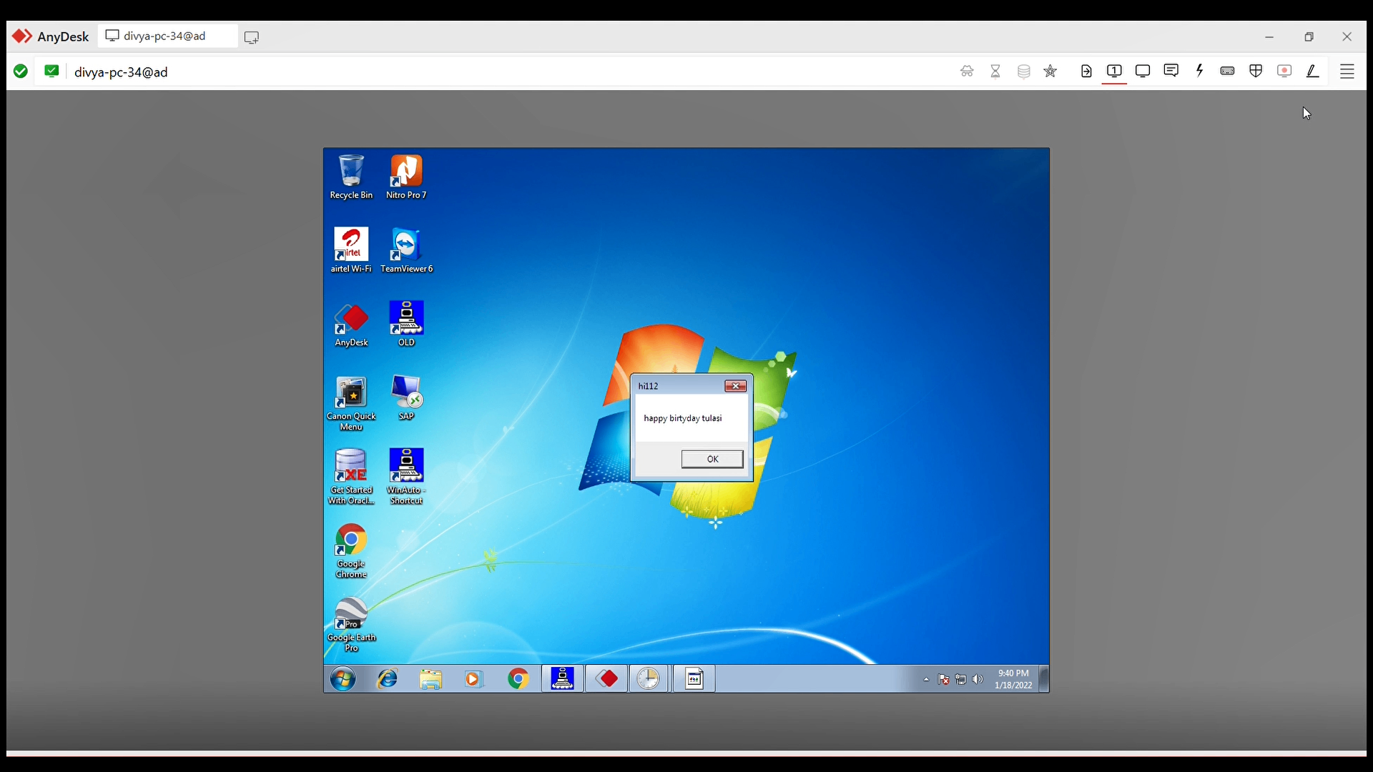

**5.Conclusion and Future Scope**

Thus by referring many existing products, previous projects and research papers based on notification and also taking into consideration problems faced by busy and software people, etc. We thought of such a project which will help to overcome the disadvantage of existing or previous system.A Desktop_based automated task and event reminder system shows task and events individuals. The users will get the schedule in-take time with notification starting and automatic alarm ringing system and message details.The scheduled reminder will not suggest any kind of idea to user .User need to schedule the remainder on particular time . This will be done without any extra cost.

The present project is a remainder application .In the future we can build a android app.This application a great furure scope . This application intelligently notifies user about the event prior enough so that user can reach event location on time. The accuracy and efficiency of application to send dynamic notifications relies upon the profiling done by user. The accuracy of notification is directly depended upon the frequency of location access. More frequently the location is accessed more accurate is the result. But frequent location access while application runs in background could reduce the battery life of device

**BIBLIOGRAPHY**

<https://plyer.readthedocs.io/en/latest/>

<https://www.geeksforgeeks.org/python-desktop-notifier-using-plyer-module/>

<https://www.youtube.com/watch?v=HHddgUtliBg>

<https://github.com/TanCodes>

<https://staging.python.org/downloads/>